**RIVER CLEANING BOAT**

**Abstract**

The River cleaning boat Project is an endeavor to clean water bodies with an ambitious mission:

1. To clean the water bodies and free from floating waste
2. Reducing human intervention
3. Faster and easy cleaning
4. Remote Operation

The core functionality of this system is centered on its ability to be controlled wirelessly using a mobile device through Wi-Fi. Users can remotely navigate the boat within the water body, enabling precise targeting of polluted areas. The collected waste is securely stored on the boat for later disposal, ensuring the efficient and responsible management of river cleanup efforts. NodeMCU is the main device of the circuit via which controls all the components of the circuit. The movement of the boat is controlled by mobile application. Battery is charged using solar panel which is a renewable energy source. Motor driver controls the speed of the motors and also detect the rotation. When the belt is start to rotate then it automatically collects the waste from water.

**Operation of the Circuit**

NodeMCU (ESP8266 12-E module) is the brain of the circuit. L298N motor driver is the driving element of the circuit. Using 100mAh solar panel we charge 3.7v lithium Battery. Solar panel is connected with IN(+ve) and IN(-ve) terminal of the charging module. The B(+ve) and B(-ve) terminal of TP4056 charging module connected with a DPDT self-locking switch pin no. 2 & 5 respectively. One 3.7v lithium battery is connected to the pin no. 1(+ve) & 6(-ve) of the DPDT self-locking switch and the other one is connected to the pin no. 3(+ve) & 4(-ve) of the DPDT self-locking switch. To make the batteries in series we use a safety jumper. If we close the jumper then it will make the batteries in series. The safety jumper should be opened during charging. The positive end of one battery and the negative end of the other battery is connected to the safety jumper. Remaining end of the two batteries are connected to +12v and GND of the motor driver respectively. GND pin of the motor driver is connected with the GND of the NodeMCU and the 5v pin of the motor driver is connected with Vin pin of NodeMCU. Left side motors are connected with OUT1 and OUT2 pin of motor driver and right-side motors are connected with OUT3 and OUT4 pin. ENA, IN1, IN2, IN3, IN4 and ENB pins of motor driver connected with D0, D1, D2, D3, D4 and D5 pin of NodeMCU respectively.

The rotation of the belt at the front of boat is controlled by two motors which are connected with a 9v battery and a switch.

The sun light incident on solar panels converts light energy to electrical energy. This generated energy is stored into the battery, the supply is given from the battery to all modules. The NodeMCU is programmed to give commands to change the motion of the boat. To give the power to the circuit the switch is to be turned on. Set up Wi-Fi connectivity between Android Mobile Application and ESP8266. Then once the device gets connected to the android application the movement of the boat can be controlled. The direction of BO motors are controlled by motor driver. With the help of a motor driver and BO motors the boat can be moved in forward, backward, left and right direction.

The conveyor belt is connected with two motors. To rotate the belt switch should be turned on. It helps to collect waste from the water surface.

**Result**

The River Cleaning Boat Project, helps to prevent water pollution and promote environmental sustainability. It plays significant role in restoring the health of our waterways. Implementing innovative technologies in river cleaning operations aimed to improve efficiency and effectiveness in debris removal. In this project we move the boat using Internet of Things(IoT).

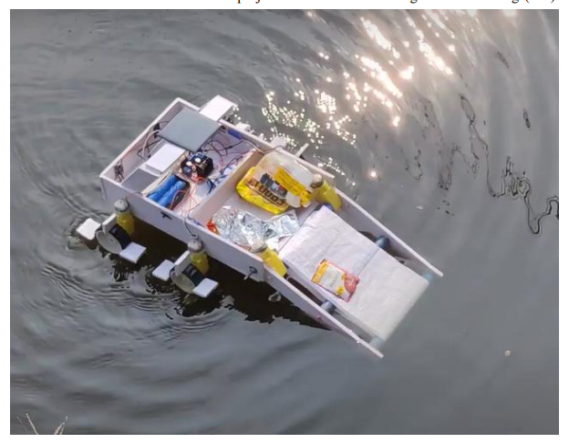

Navigation commands for boat helps to control the boat in forward, backward, left, right direction. The boat gives out the efficient cleaning mechanism with the help of mobile app.

* Sampurna Pal (ECE, 4TH YEAR)
* Shova Varma (ECE, 4TH YEAR)
* Ayan Pal (ECE, 4TH YEAR)
* Amit Kumar Bakshi (ECE, 4TH YEAR)